

LAB REPORT

Course Title: Software Project -01
Course Code: CSE226
Semester: Fall 2023

Course Teacher

Sharun Akter Khushbu
Senior Lecturer
Dept. of CSE, DIU

Submitted by

Name: Shahriar Ahmed Shovo Name: Shraboni Goswami

ID: 221-15-5456 ID: 221-15-5929

Section: 61_K Section: 61_K

Submitted Date: 21 Nov 2023

This Report Presented in Partial Fulfillment of the Requirements for the Degree of Bachelor of Science in Computer Science and Engineering.

ABSTRACT

This report investigates the functionality and implications of free converting blogger websites, focusing on their role in content creation and format transformation within the digital landscape. As online platforms increasingly emphasize multimedia content, these websites offer users a cost-effective means to convert diverse file formats seamlessly. The report evaluates the advantages, such as accessibility and user-friendliness, as well as the challenges associated with the use of these free services. Concerns related to quality assurance, privacy, and potential security vulnerabilities are analyzed, offering a comprehensive overview for users considering the adoption of free converting blogger websites. By examining the features and drawbacks, this report aims to provide valuable insights into the dynamics of these platforms, aiding users in making informed decisions regarding their content creation and conversion strategies.

TABLE OF CONTENTS

CONTENTS | PAGE
Abstract | 2
Table of contents | 3
CHAPTER
CHAPTER 1: INTRODUCTION | 4
1.1 Introduction | 4
1.2 Motivation | 4
1.3 Merits and Demerits | 4-6
CHAPTER 2: BACKGROUND | 1
2.1 Introduction | 1
2.2 Related Website | 1
Chapter 3: DESIGN, FIGURE & SPECIFICATION | 2-14
3.1 Front-end Design | 2-14
CHAPTER 4: DISCUSSION & CONCLUTION | 15
5.1 Discussion and Conclusion | 15
REFERENCES | 16

INTRODUCTION

2.1 Introduction

By converting a website into a blogger-friendly space, organizations open themselves up to a wealth of opportunities for collaboration, content creation, and audience engagement. This report will explore the strategies and best practices involved in this transformation, shedding light on how businesses can harness the potential of bloggers to enhance their digital footprint and stay at the forefront of the rapidly evolving online landscape. In doing so, we aim to provide insights that empower businesses to make informed decisions about optimizing their websites for collaboration with bloggers, thereby unlocking new avenues for growth and influence in the digital realm.

1.2 Motivation
Join us on a journey through the motivations fueling the integration of AI into website conversion tools, as we uncover the potential for innovation, efficiency gains, and a more responsive digital presence. This report aims to shed light on the compelling reasons driving this technological evolution, providing insights for businesses and developers seeking to harness the power of AI for optimal website conversion.

1.3 Merits and Demerits
Merits and Demerits of Free Online Video Downloaders:
Merits: Cost-effective, easy to use, no installation needed, cross-platform accessibility, multiple format options.
Demerits: Legal and ethical concerns, potential quality loss, safety and security risks, limited features, dependence on internet connection, privacy concerns, reliability issues, pop-ups and ads. In conclusion, while useful, caution is needed due to legal, security, and privacy issues.

Merits and Demerits of Audio Converters
Merits: Versatility, space management, tailored quality, batch conversion, device integration, audio extraction from videos.
Demerits: Loss of quality, dependency on software, potential for malware, time-consuming conversions, loss of metadata, limited format support. Audio converters offer value but can have quality and security drawbacks.
Merits and Demerits of Online Resume Makers
Merits: User-friendly interface, professional designs, customization, guided content suggestions, cloud storage, instant formats and downloads, integration with job platforms. Demerits: Subscription fees, generic templates, limited personalization, privacy concerns, internet dependency, over-reliance on templates, hidden costs. Online resume makers streamline creation but can pose privacy and customization challenges.
Merits and Demerits of Online Article Rewriters
Merits: Time and effort saving, content spinning for SEO, inspiration and idea generation, avoiding plagiarism.
Demerits: Quality of output, loss of original meaning, lack of creativity, search engine issues, ethical concerns, legal issues, dependency on technology. Article rewriters offer efficiency but come with quality and originality concerns.

Merits and Demerits of Online Grammar Checkers
Merits: Immediate feedback, accessibility, consistency, learning tool, multifunctionality, support for multiple languages, customization.
Demerits: Not infallible, over-reliance, contextual mistakes, privacy concerns, standardization, potential costs, limited understanding of creative writing, network dependency. Grammar checkers aid writing but require balanced usage.

Merits and Demerits of Facebook and YouTube Video Downloaders
Merits: Offline viewing, backup and archival, educational purposes, flexibility, avoiding ads and interruptions, speed.
Demerits: Copyright infringement, loss of revenue for creators, malware and security concerns, quality degradation, limitations on updates, terms of service violations, no support or guarantees, moral and ethical concerns. Caution needed when downloading videos due to legality and ethical considerations.

Merits and Demerits of Online PDF Compressors
Merits: Ease of use, no software installation, free options available, file sharing, web integration, faster uploading and downloading.
Demerits: Quality reduction, privacy concerns, file size limitations, dependence on internet connectivity, ads and upselling, temporary file storage, limited features. Online PDF compressors offer convenience but might compromise quality and privacy.
Merits and Demerits of Online PPT/PPTX Converters
Merits: Versatility, ease of use, no software installation needed, accessibility, free options, integration with cloud services.
Demerits: Quality concerns, privacy and data security, file size limitations, dependence on internet connectivity, advertisements, loss of interactivity, temporary storage of files, limited features. Consider pros and cons for online PPT/PPTX conversion.

CHAPTER 2

BACKGROUND

2.1 Introduction
This Ai Eyes converting website will generally provide different types of services. The design or diagram and structure of the website we have tried to make it very simple so that common people can easily reach it and use it. So, for this we have created this whole background through blogger and some many website.

2.2 Related Works
Around some related services are available. We believe that, the available services are serving users properly and so that this type of solutions can be effective in our country also. Some of those services are given below.

https://www.freedownloadmanager.org/

https://www.freepdfconvert.com/

https://www.ilovepdf.com/compress_pdf

https://www.canva.com/create/resumes/

https://www.webtoptools.com/video/facebook-video-downloader/?gclid=EAIaIQobChMIk-zzz4_UggMVHR-DAx0o8wEIEAAYASAAEgKAVPD_BwE

https://online-audio-converter.com/

https://convertio.co/document-converter/

https://resume.io/

https://articlerewritertool.com/

https://quillbot.com/grammar-check

https://video-converter.com/
https://www.ocr2edit.com/scanned-image-to-text https://smallpdf.com/compress-pdf https://cloudconvert.com/presentation-converter

CHAPTER 3

DESIGN SPECIFICATION

4.1 Front-end Design
Designing a blogger's homepage for a website conversion involves creating an inviting and functional interface to attract and engage visitors. Since you're focusing on a blogger who utilizes free tools, here's a simple yet effective frontend design approach:

1. Clean and Minimalist Layout: opt for a clean and uncluttered design to enhance readability and user experience. Use a minimalist layout with ample white space to highlight essential elements.
2. Responsive Design: Ensure the design is responsive, adapting seamlessly to various screen sizes and devices.
3. Header with Blog Name and Navigation: Place the blog's name or logo prominently in the header. Include a straightforward navigation menu with categories or tags for easy exploration.

- Featured Blog Posts: Showcase featured or latest blog posts with concise titles, snippets, and eye-catching images. Consider using a carousel or grid layout to display multiple posts.
5. About the Blogger Section: Introduce the blogger with a brief bio, possibly accompanied by a friendly photo. Share the blogger's interests, mission, or any other relevant information.
6. Subscribe and Social Media Links: Include a noticeable subscription box for newsletters. Integrate social media icons, linking to the blogger's profiles for increased connectivity.
- Search Bar: Implement a simple and accessible search bar for users to find specific content easily.
8. Category or Tag Cloud: Display categories or tags in a visually appealing cloud format, enabling users to explore content by topic.
9. Footer with Essential Links: Design a clean footer containing links to essential pages, such as the about page, contact information, and privacy policy.
- Basic Color Scheme: Choose a basic color scheme that aligns with the blogger's style. Consider using free tools for color selection.
11. Typography: Select readable and web-friendly fonts to enhance the overall legibility of the content.
12. Call-to-Action (CTA): Strategically place CTAs, encouraging visitors to subscribe, share, or explore more content.

3.1.1: Home Page
Our websites homepage simply designs for user comfort. Anyone can easily use it their needs. This home page has all converting tools. Which helps us convert many files, videos, image etc.

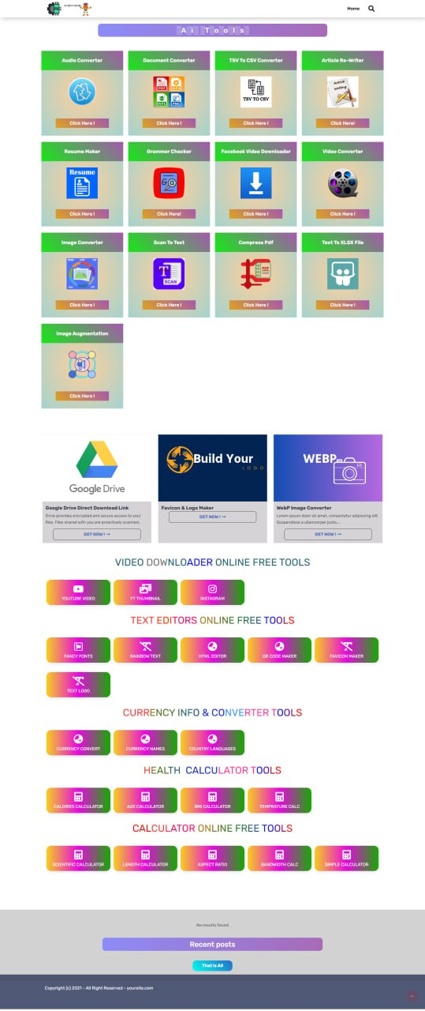

Figure 3.1.1: Home Page
3.1.2: Audio Converter page:

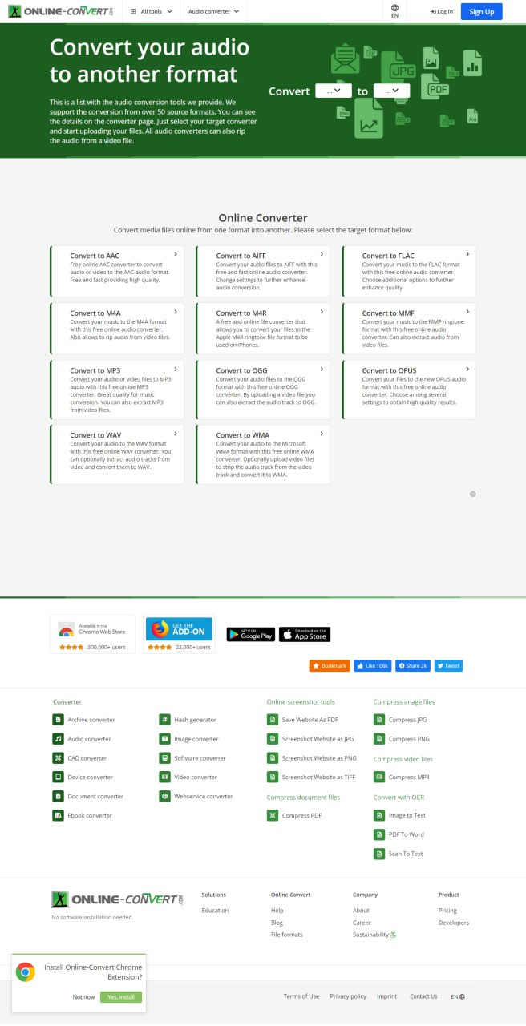
Figure 3.1.2: Audio Converter page:

3.1.3: Document Converter Page

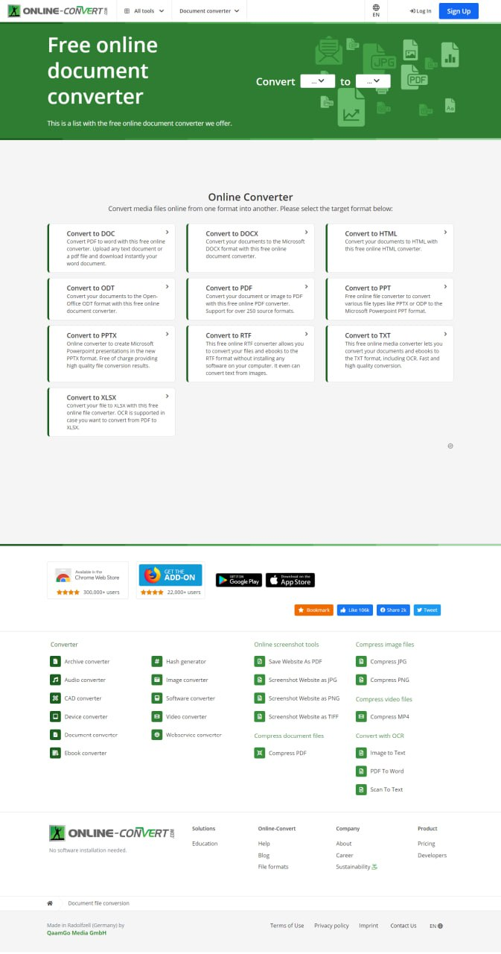

Figure 3.1.3: Document Converter Page

3.1.4: TSV to CSV Converter Page
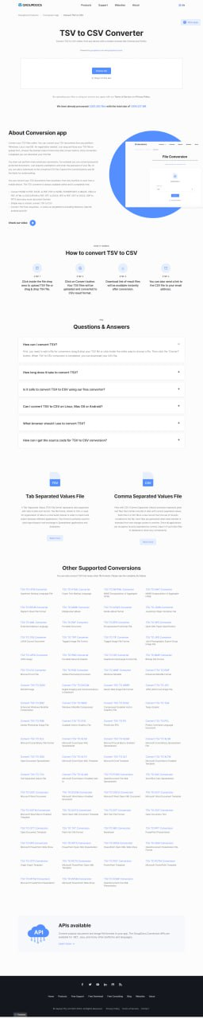
Figure 3.1.4: TSV to CSV Converter Page

3.1.5: Article Re-writer Page

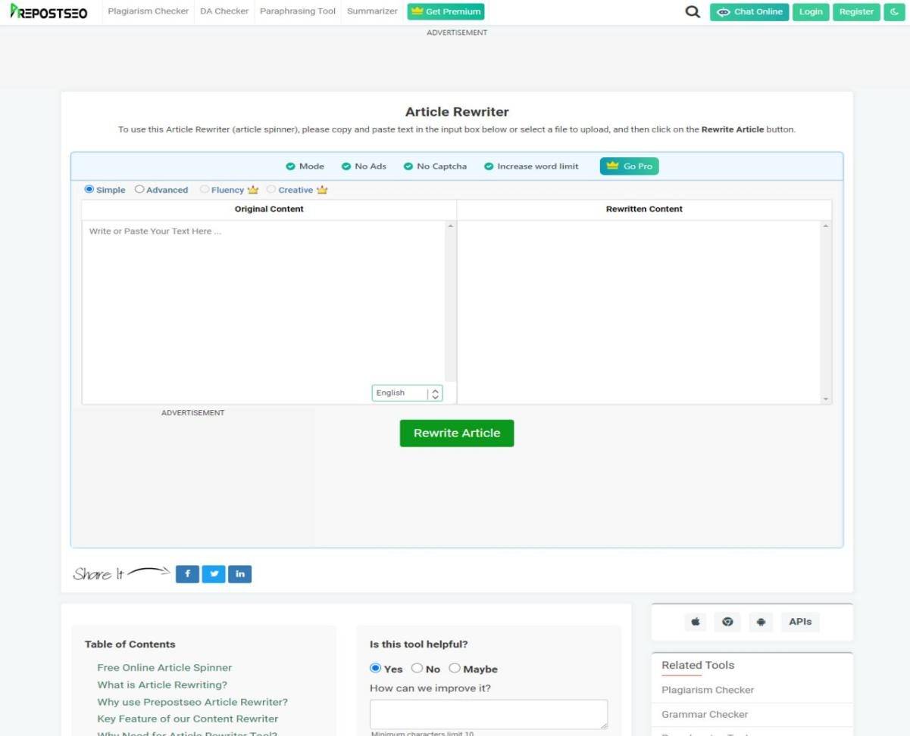

Fig 3.1.5: Article Re-writer Page

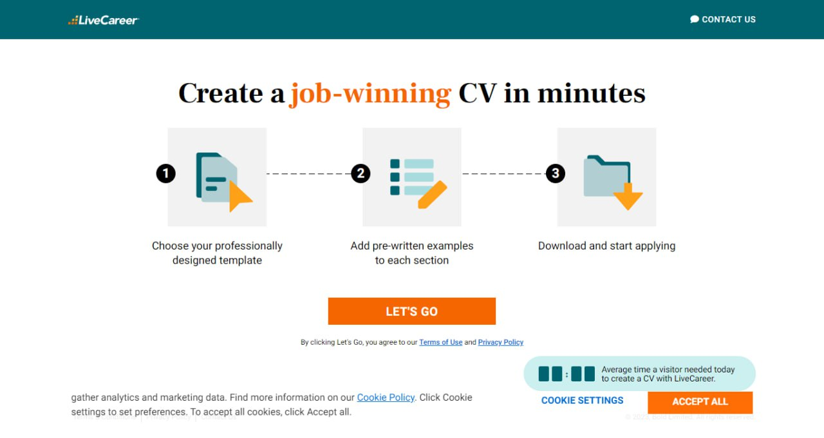
3.1.6: Resume Maker Page

Fig 3.1.6: Resume Maker Page

3.1.7: Grammar Checker Page
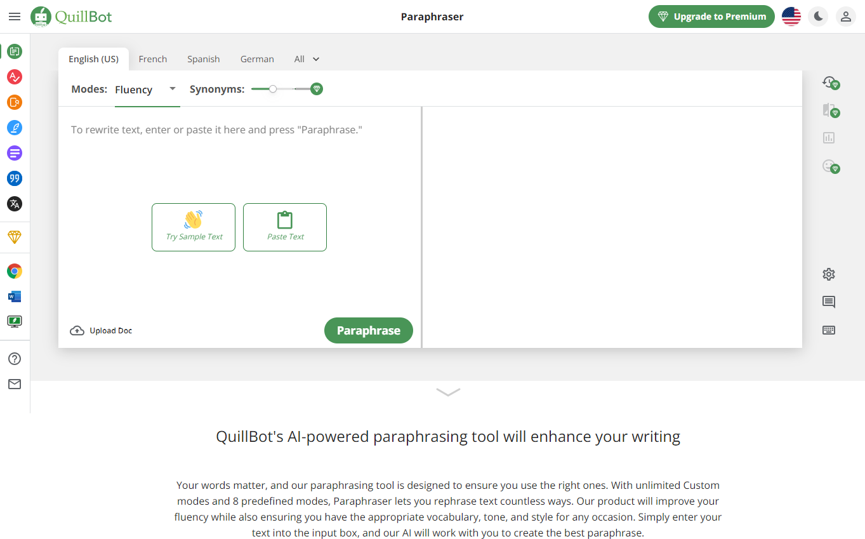

Fig 3.1.7: Grammar Checker Page

3.1.8: Facebook Video Downloader Page

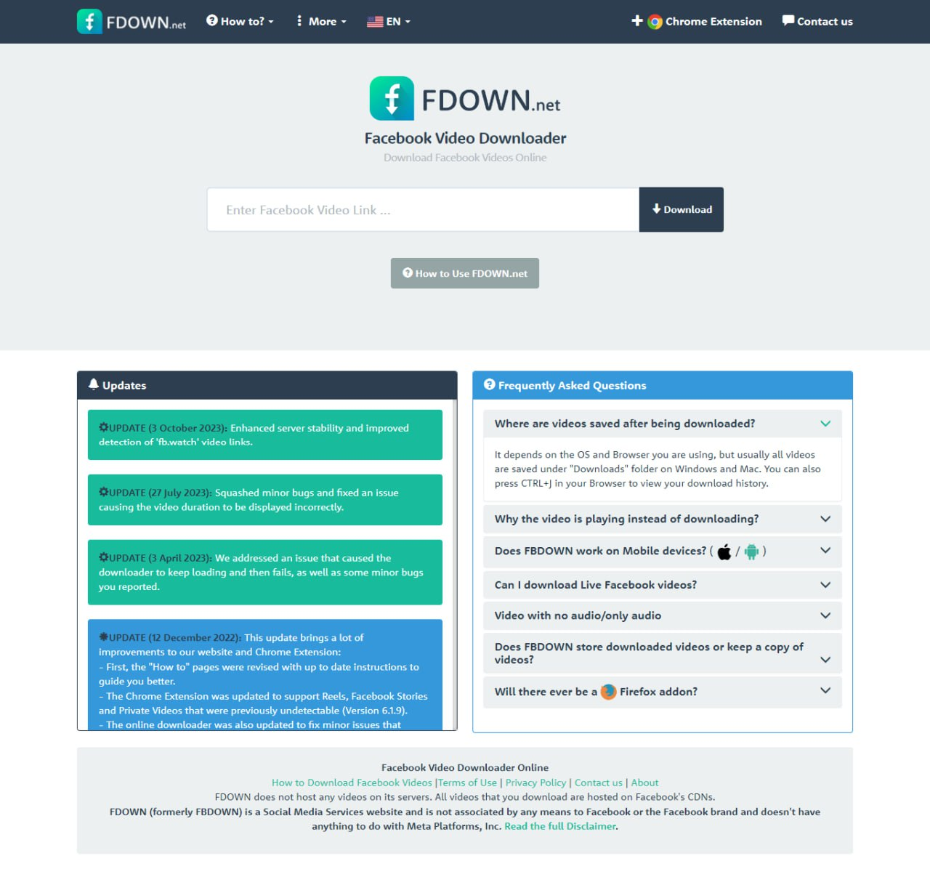

3.1.9: Video Converter Page
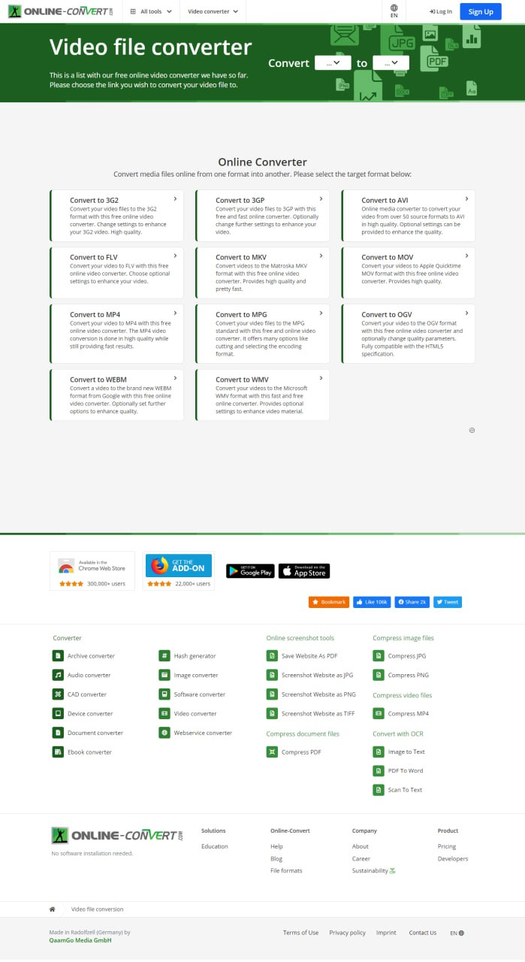
Figure 3.1.9: Video Converter Page

3.1.10: Compress PDF Page
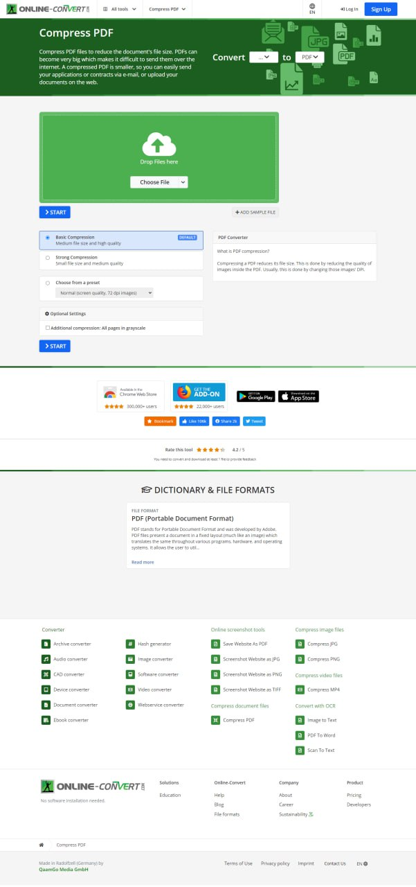

3.1.11: Image Converter

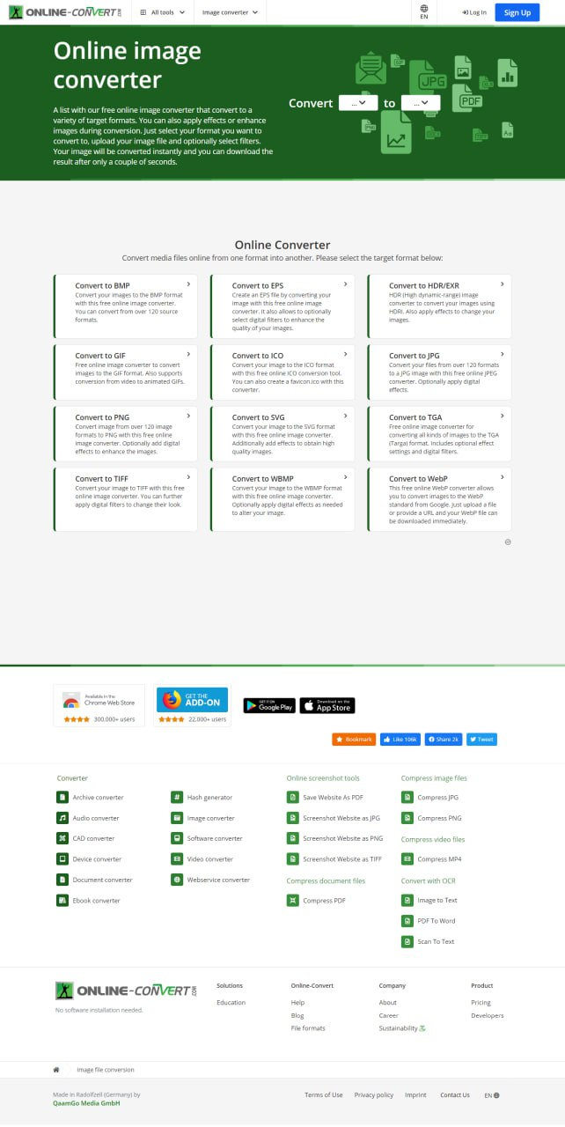

3.1.12: YouTube video downloader
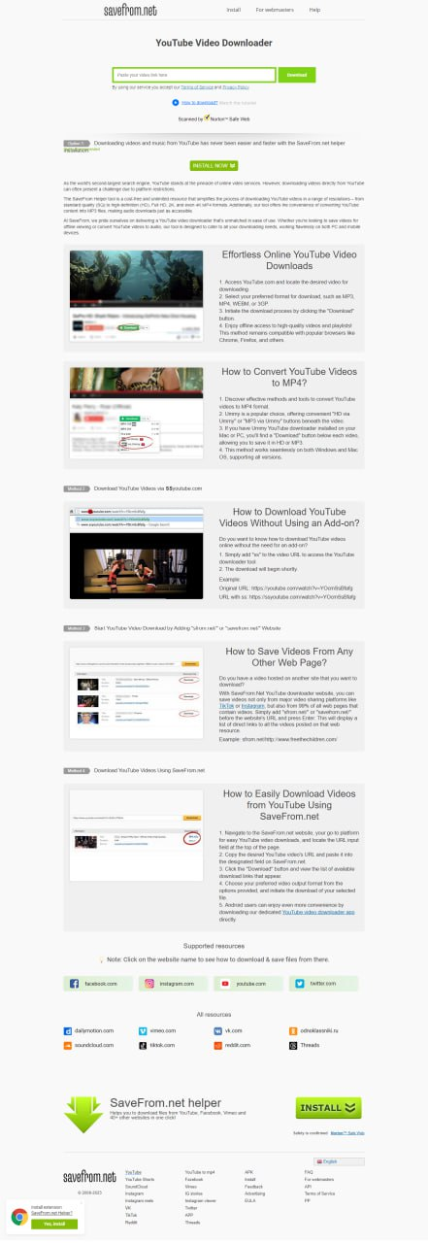

CHAPTER 4

DISCUSSION & CONCLUSION

Discussion: The adoption of free tools for converting websites into blogger-friendly platforms presents a cost-effective avenue for individuals with budget constraints. Despite potential limitations in customization, the discussion centers on the strategic use of available features to create a user-friendly and visually appealing frontend. Emphasis is placed on integrating essential elements such as subscription forms and social media links within the constraints of free tools.

Conclusion: In conclusion, leveraging free tools for website conversion allows bloggers to establish an online presence without a substantial financial investment. While acknowledging limitations, bloggers can navigate these constraints to create engaging frontends that effectively communicate their brand. The cost-effectiveness of free tools becomes a key advantage, enabling bloggers to express creativity and connect with audiences in the ever-evolving digital landscape.

REFERENCES

https://www.freedownloadmanager.org/

https://www.freepdfconvert.com/

https://www.ilovepdf.com/compress_pdf

https://www.canva.com/create/resumes/

https://www.webtoptools.com/video/facebook-video-downloader/?gclid=EAIaIQobChMIk-zzz4_UggMVHR-DAx0o8wEIEAAYASAAEgKAVPD_BwE

https://online-audio-converter.com/

https://convertio.co/document-converter/

https://resume.io/

https://articlerewritertool.com/

https://quillbot.com/grammar-check

https://video-converter.com/
https://www.ocr2edit.com/scanned-image-to-text
https://smallpdf.com/compress-pdf
https://cloudconvert.com/presentation-converter

